Ministry of Education and Science of Ukraine
National Technical University of Ukraine
"Kyiv Polytechnic Institute named after Igor Sikorsky"
Educational and Scientific Institute of Atomic and Thermal Energy
Department of Digital Technologies in Energy

Graphics work
Topic: «Operations on texture coordinates.»
from the discipline: «Visualization of graphical and geometric information»

Variant 16

Performed by:
student of the TR-43mp group
Tyshchuk R.O.

Checked by:
Kaleniuk O. S.

Kyiv – 2024
1. Task

- Reuse texture mapping from Control task.
- Implement texture scaling (texture coordinates) scaling rotation around user specified point- odd variants implement scaling, even variants implement rotation
- It has to be possible to move the point along the surface (u,v) space using a keyboard. E.g. keys A and D move the point along u parameter and keys W and S move the point along v parameter.

2. Theory

2.1 3D Geometry and Parametric Surfaces
In computer graphics, 3D geometry is the basis of all 3D models. A 3D model is basically a collection of vertices, edges, and faces that define the shape of an object. These are often represented as mathematical points in a 3D coordinate system: X, Y, Z.
Parametric surfaces are defined by mathematical functions that map two parameters, typically denoted as u and v, to 3D coordinates. A parametric surface can be represented by three functions:

P(u,v)=(x(u,v),y(u,v),z(u,v))

Where x(u, v), y(u, v) and z(u, v) define the position of a point on the surface in 3D space. This can give quite complex shapes with relatively simple sets of equations.
As an example, a torus (the shape of a doughnut) can be described parametrically by the following equations:

x(u,v)=(R+r⋅cos(v))⋅cos(u)
y(u,v)=(R+r⋅cos(v))⋅sin(u)
z(u,v)=r⋅sin(v)

- u and v are parameters that vary in certain ranges, often between [0, 2π].
- R is the radius of the central circle of the torus.
- r is the radius of the tube composing the torus.

This is a parametric representation where, for different step sizes of u and v, it allows us to sample points on the surface, which can then be used in the construction of the 3D model.
2.2 Texture Mapping and UV Coordinates
Texture mapping is the process of applying a 2D image (texture) to a 3D model. It's a crucial element in 3D graphics to introduce realism and detail without the need for complicated geometry. In order to apply a texture, we have to define the correspondence between points on the 3D model (vertices) and points on the 2D texture (UV coordinates).
UV mapping is the way to map a 3D surface onto a 2D plane. U and V refer to the horizontal and vertical axes of the 2D texture, respectively. For each vertex of a 3D model, a UV coordinate would be assigned, describing to the renderer from where exactly it should sample the texture. Usually, these are normalized in the range of [0, 1].
Now consider some UV coordinates for the corners of such a 3D model, if it had a simple rectangular surface:

Bottom-left corner: (0, 0)
Bottom-right corner: (1, 0)
Top-left corner: (0, 1)
Top-right corner: (1, 1)

The unwrap is an important step to making the accuracy of texture mapping and, therefore, is an important concept on how to render a realistic 3D model in computer graphics.

2.3 WebGL and 3D Rendering
WebGL is the JavaScript API for rendering interactive 3D and 2D graphics in the browser without the use of plug-ins. WebGL provides a low-level interface between JavaScript and the Graphics Processing Unit (GPU), using OpenGL ES.
WebGL operates by setting up a rendering context inside an HTML <canvas> element wherein 3D models and textures are drawn. Here's basically how the pipeline for rendering in WebGL goes:
1. Processing Vertices: The vertex shader executes and processes vertices of the 3D model. The position of the vertices is transformed by this process from object space to screen space, using matrix operations.
2. Rasterization: The fragment shader takes the result of every pixel and figures out its color based on lighting, textures, etc.
3. Texturing: In the fragment shader, textures are bound according to the UVs coming from the vertices of the model. The renderer samples from this texture at those coordinates and then combines it with colors of that model and light.
With the help of shaders and buffers, WebGL can perform the rendering of complex 3D scenes right in the browser. This is especially important for real-time applications, such as 3D visualizations, games, and interactive websites.

2.4 Normals and Tangents in 3D Graphics
Normals and tangents are used as vectors in 3D graphics. The main purpose of such vectors is to define the surface orientation and they are substantial when performing lighting and texture mapping.

- Normals: A normal vector is an arrow oriented perpendicular to a surface at a particular point. In graphics, it is used to calculate lighting-interactions of light with the surface. The direction of the normal determines how light reflects off the surface; hence, it determines what the surface will look like.
- Tangents: A tangent is a vector that lies in the plane of the surface at a given point. It is used mainly in normal mapping. Normal maps store detailed surface information, such as bumps or wrinkles, and require tangents to map correctly the normals onto the 3D model.

Normal and tangent calculation plays an important role in 3D rendering to realistically achieve effects like the simulation of light interaction with a surface.

3. Implementation Details

3.1 Vertex Shader
This vertex shader is supposed to process vertex data and transform it according to the view of the camera. It accepts several inputs: vertex positions, normals, tangents, texture coordinates (UVs), and finally, transformation matrices for a model, view, and projection. In addition, lighting information is given through uniforms about the position of the light and material textures: diffuse, normal, and specular.
One of the critical operations involves the rotation of the UV coordinates with respect to an angle and a point, enabling dynamic manipulation of textures. The function getRotatedUV computes the rotated texture coordinates based on a point and angle. This transformation is essential to achieve effects such as rotating texture maps or dynamically changing the orientation of textures during the process of rendering.
The normal vector is adjusted based on the tangent and bitangent vectors, taking into account the normal map to enhance surface details, which is common in modern rendering techniques for achieving high realism in lighting interactions.
The shader now calculates the final fragment color by addition of ambient, diffuse, and specular lighting components. This realizes realistic lighting interactions with the model, depending on its material properties and the position of the light source.

3.2 Fragment Shader
The fragment shader will get the color computed from the vertex shader and output the final color for each pixel. In this case, the fragment shader passes the computed fragColor to the framebuffer.

3.3 Texture Loading
The textures are loaded by using the LoadTexture function, which creates a texture in WebGL, binds it, and then loads an image asynchronously. The function handles texture parameters such as wrapping and filtering modes, which control how textures behave when they're scaled or tiled.

3.4 Model Creation and Buffering
The ModelBuilder class is responsible for the generation of the model geometry. Based on the input parameters, it calculates the vertices, normals, tangents, and texture coordinates. This class allows flexible creation of models, defining the shape and UV coordinates while taking care of proper normal and tangent calculations to support lighting effects.

3.5 Interaction with the Model
The TexCoordDrawer class will listen for user interactions such as mouse movement and click events to change the UVs dynamically. It listens for events from these mouse events and changes the model's texture coordinates based on this. This way, users can manipulate the UV rotation interactively because the rotation is updated in real time.

4. User's instruction

The user experience with this work is designed to be interactive, intuitive, and visually engaging.

4.1 Interactive Input Controls
- The user is given multiple input controls to adjust parameters that influence the visual output. These controls include:
  - U and V Steps: Numeric inputs for fine-tuning the steps for the U and V axes, which will likely affect the resolution or smoothness of the generated surface.
  - A, B, C, D: These numeric inputs allow the user to manipulate parameters that might control the shape or properties of the surface, providing a level of customization for the user.
  - Angle: A slider to adjust the rotation of the surface, giving the user dynamic control over how the model is viewed.
- The inputs are styled to look sleek with soft borders, a subtle background gradient, and responsive feedback when hovered or focused.

4.2 Real-Time Feedback
- The coordinates display dynamically updates to show the user’s interaction with the 3D model. This helps the user track their changes or understand the positioning of their input in real-time.
- The user can adjust the surface's parameters and immediately see the changes reflected on the canvas, providing an engaging and responsive experience.

4.3 Canvas for Visualization
- There are two canvas elements (uvcanvas and webglcanvas), which might represent different renderings or layers of the surface (e.g., one for the texture map and the other for the surface itself).
- The user can observe the changes in the surface and texture as they modify the inputs, which makes the experience highly interactive. This real-time rendering of the 3D model offers an immersive feeling.

4.4 Educational and Experimental
- The design is likely aimed at users interested in exploring 3D surfaces and mathematical visualizations. The title ("Virich Cyclic Surface") suggests that this is a tool for mathematical exploration, making it suitable for both learning and experimentation. The controls allow users to explore the effect of changing mathematical parameters on the 3D surface, which could be used for educational purposes in mathematics, computer graphics, or related fields.

4.5 Overall Feel
- The overall experience is polished and professional, with an emphasis on clarity, usability, and real-time interaction. The dark background with light text creates a visually comfortable environment for long-term use, while the dynamic model visualization offers an engaging and interactive learning experience.

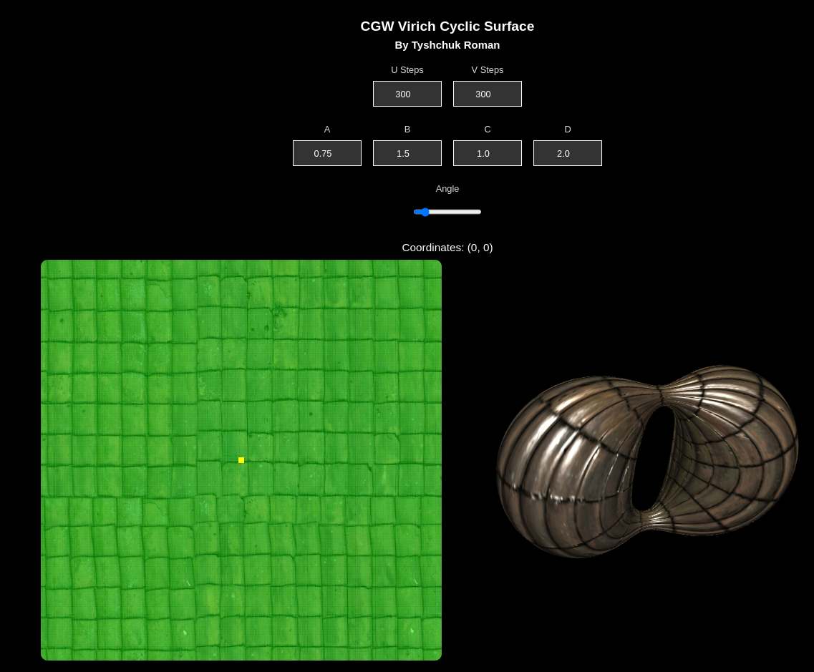

Рис. 4.1

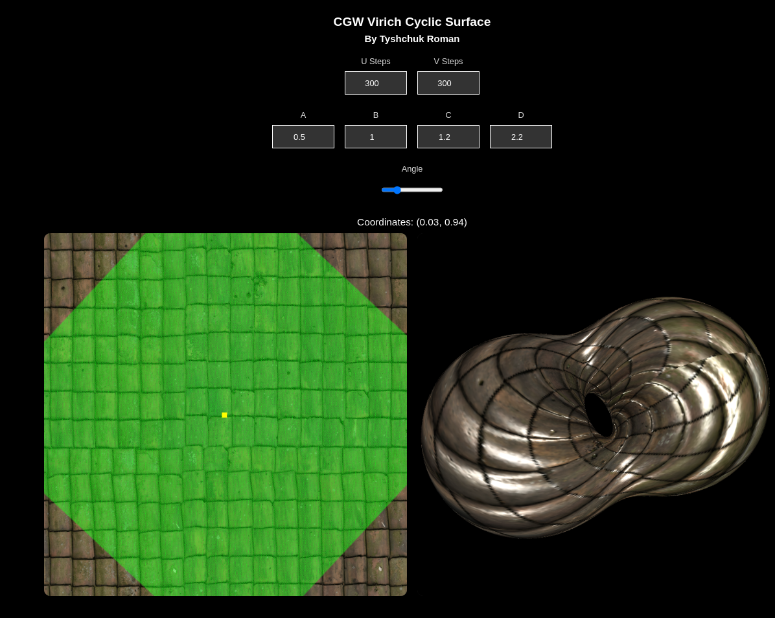

Рис. 4.2
5. Source code

5.1 Shaders

// Vertex shader
const vertexShaderSource = `#version 300 es

in vec3 inVertex;
in vec3 inNormal;
in vec3 inTangent;
in vec2 inUV;

uniform mat4 projectionMatrix;
uniform mat4 modelMatrix;
uniform mat4 normalMatrix;

uniform vec3 lightLocation;

uniform sampler2D diffuseTexture;
uniform sampler2D normalTexture;
uniform sampler2D specularTexture;

uniform vec2 point;
uniform float angle;

out vec3 fragColor;

vec2 getRotatedUV() {
vec2 uv = inUV - point;
float cosTheta = cos(angle);
float sinTheta = sin(angle);

uv = vec2(
uv.x * cosTheta - uv.y * sinTheta,
uv.x * sinTheta + uv.y * cosTheta
);

return uv + point;
}

vec3 getNormal(vec2 uv)
{
vec3 normal = normalize(mat3(normalMatrix) * inNormal);
vec3 tangent = normalize(mat3(normalMatrix) * inTangent);

normal = normalize(normal - dot(tangent, normal) * tangent);

vec3 bitangent = cross(tangent, normal);
vec3 normalMap = texture(normalTexture, uv).rgb;
normalMap = 2.0 * normalMap - vec3(1.0, 1.0, 1.0);

mat3 TBN = mat3(tangent, bitangent, normal);
return normalize(TBN * normalMap);
}

void main() {
const float ambientFactor = 0.2;
vec2 uv = getRotatedUV();
vec3 color = texture(diffuseTexture, uv).rgb;
float specularFactor = pow(texture(specularTexture, uv).r, 1.0);

vec4 vertex = modelMatrix * vec4(inVertex, 1.0);
vertex /= vertex.w;

vec3 N = getNormal(uv);
vec3 L = normalize(vertex.xyz - lightLocation);
vec3 V = normalize(-vertex.xyz);

if( dot(N, V) < 0.0) {
N = -N;
}

vec3 ambient = color * ambientFactor;
vec3 diffuse = vec3(max(dot(N, -L), 0.0)) * color * (1.0 - ambientFactor);
vec3 R = reflect(L, N);
vec3 specular = vec3(specularFactor) * pow(max(dot(V, R), 0.0), 8.0);

fragColor = ambient + diffuse + specular;
gl_Position = projectionMatrix * vertex;
}`;

// Fragment shader
const fragmentShaderSource = `#version 300 es
precision highp float;

in vec3 fragColor;
out vec4 outColor;

void main() {
outColor = vec4(fragColor, 1.0);
}`;

5.2 Model Builder

function ModelBuilder() {
const a = get('A');
const b = get('B');
const c = get('C');
const d = get('D');

const uSteps = get('USteps');
const vSteps = get('VSteps');

const uMin = 0.0;
const uMax = Math.PI * 2;

const vMin = 0.0;
const vMax = Math.PI * 2;

const du = (uMax - uMin) / uSteps;
const dv = (vMax - vMin) / vSteps;

this.f = function(v) {
return (a * b) / Math.sqrt(a ** 2 * Math.sin(v) ** 2 + b ** 2 * Math.cos(v) ** 2);
}

this.fx = function(t, v) {
const fv = this.f(v, a, b);
return 0.5 * (fv * (1 + Math.cos(t)) + (d ** 2 - c ** 2) * (1 - Math.cos(t)) / fv) * Math.cos(v);
}

this.fy = function(t, v) {
const fv = this.f(v, a, b);
return 0.5 * (fv * (1 + Math.cos(t)) + (d ** 2 - c ** 2) * (1 - Math.cos(t)) / fv) * Math.sin(v);
}

this.fz = function(t, v) {
const fv = this.f(v, a, b);
return 0.5 * (fv - (d ** 2 - c ** 2) / fv) * Math.sin(t);
}

this.build = function() {
const vertices = [];
const uvs = [];
const indices = [];

for (let i = 0; i <= uSteps; i++) {
const u = uMin + i * du;
for (let j = 0; j <= vSteps; j++) {
const v = vMin + j * dv;

const x = this.fx(u, v);
const y = this.fy(u, v);
const z = this.fz(u, v);

vertices.push(x, y, z);
uvs.push(normalizeUV(u, uMin, uMax), normalizeUV(v, vMin, vMax));
}
}

for (let i = 0; i < uSteps; i++) {
for (let j = 0; j < vSteps; j++) {
const topLeft = i * (vSteps + 1) + j;
const topRight = i * (vSteps + 1) + (j + 1);
const bottomLeft = (i + 1) * (vSteps + 1) + j;
const bottomRight = (i + 1) * (vSteps + 1) + (j + 1);

indices.push(topLeft, bottomLeft, bottomRight);
indices.push(topLeft, bottomRight, topRight);
}
}

const {normals, tangents} = calculateNormalsAndTangents(vertices, uvs, indices);
return { vertices, normals, tangents, uvs, indices };
}
}

5.3 Model

function Model(gl, shProgram) {
this.iVertexBuffer = gl.createBuffer();
this.iNormalBuffer = gl.createBuffer();
this.iTangentBuffer = gl.createBuffer();
this.iUVBuffer = gl.createBuffer();
this.iIndexBuffer = gl.createBuffer();

this.idTextureDiffuse = LoadTexture(gl, "./textures/diffuse.jpg");
this.idTextureNormal = LoadTexture(gl, "./textures/normal.jpg");
this.idTextureSpecular = LoadTexture(gl, "./textures/specular.jpg");

this.point = [0.5, 0.5];
this.uvBuffer = [];
this.indexBuffer = [];

this.count = 0;

this.BufferData = function(vertices, normals, tangents, uvs, indices) {
gl.bindBuffer(gl.ARRAY_BUFFER, this.iVertexBuffer);
gl.bufferData(gl.ARRAY_BUFFER, new Float32Array(vertices), gl.STATIC_DRAW);

gl.bindBuffer(gl.ARRAY_BUFFER, this.iNormalBuffer);
gl.bufferData(gl.ARRAY_BUFFER, new Float32Array(normals), gl.STATIC_DRAW);

gl.bindBuffer(gl.ARRAY_BUFFER, this.iTangentBuffer);
gl.bufferData(gl.ARRAY_BUFFER, new Float32Array(tangents), gl.STATIC_DRAW);

gl.bindBuffer(gl.ARRAY_BUFFER, this.iUVBuffer);
gl.bufferData(gl.ARRAY_BUFFER, new Float32Array(uvs), gl.STATIC_DRAW);

gl.bindBuffer(gl.ELEMENT_ARRAY_BUFFER, this.iIndexBuffer);
gl.bufferData(gl.ELEMENT_ARRAY_BUFFER, new Uint32Array(indices), gl.STATIC_DRAW);

this.uvBuffer = uvs;
this.indexBuffer = indices;

this.count = indices.length;
};

this.Draw = function() {
gl.bindBuffer(gl.ARRAY_BUFFER, this.iVertexBuffer);
gl.vertexAttribPointer(shProgram.iAttribVertex, 3, gl.FLOAT, false, 0, 0);
gl.enableVertexAttribArray(shProgram.iAttribVertex);

gl.bindBuffer(gl.ARRAY_BUFFER, this.iNormalBuffer);
gl.vertexAttribPointer(shProgram.iAttribNormal, 3, gl.FLOAT, false, 0, 0);
gl.enableVertexAttribArray(shProgram.iAttribNormal);

gl.bindBuffer(gl.ARRAY_BUFFER, this.iTangentBuffer);
gl.vertexAttribPointer(shProgram.iAttribTangent, 3, gl.FLOAT, false, 0, 0);
gl.enableVertexAttribArray(shProgram.iAttribTangent);

gl.bindBuffer(gl.ARRAY_BUFFER, this.iUVBuffer);
gl.vertexAttribPointer(shProgram.iAttribUV, 2, gl.FLOAT, false, 0, 0);
gl.enableVertexAttribArray(shProgram.iAttribUV);

gl.bindBuffer(gl.ELEMENT_ARRAY_BUFFER, this.iIndexBuffer);

gl.activeTexture(gl.TEXTURE0);
gl.bindTexture(gl.TEXTURE_2D, this.idTextureDiffuse);

gl.activeTexture(gl.TEXTURE1);
gl.bindTexture(gl.TEXTURE_2D, this.idTextureNormal);

gl.activeTexture(gl.TEXTURE2);
gl.bindTexture(gl.TEXTURE_2D, this.idTextureSpecular);

gl.uniform2fv(shProgram.iPoint, this.point);
gl.uniform1f(shProgram.iAngle, parseFloat(document.getElementById('Angle').value) * (Math.PI / 180.0));

gl.drawElements(gl.TRIANGLES, this.count, gl.UNSIGNED_INT, 0);
}

this.CreateSurfaceData = function() {
let builder = new ModelBuilder();
const { vertices, normals, tangents, uvs, indices } = builder.build();
this.BufferData(vertices, normals, tangents, uvs, indices);
}
}

